SELECT DO_Piece, DO_Type
FROM F_DOCENTETE
INNER JOIN F_COMPTET on (F_DOCENTETE.DO_Tiers = F_COMPTET.CT_Num)
WHERE F_DOCENTETE.DO_Domaine = 0 AND F_DOCENTETE.DO_Type = 7
AND ISNULL(F_COMPTET.FACTUREPAPYRUS, '') != 'NON'
AND ISNULL(F_DOCENTETE.IMPRIMEPAPYRUS, '') = ''
AND F_DOCENTETE.DO_Date > '20210501'

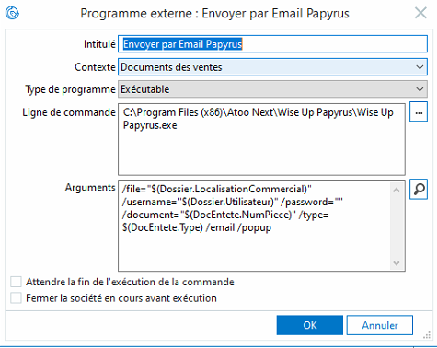

Arguments :
/file="$(Dossier.LocalisationCommercial)" /username="$(Dossier.Utilisateur)" /password="" /document="$(DocEntete.NumPiece)" /type=$(DocEntete.Type) /email /popup

