ECOTAXE PRESTASHOP
Tableau de bord > International > Taxes
Options des taxes :
Eco-participation + TVA
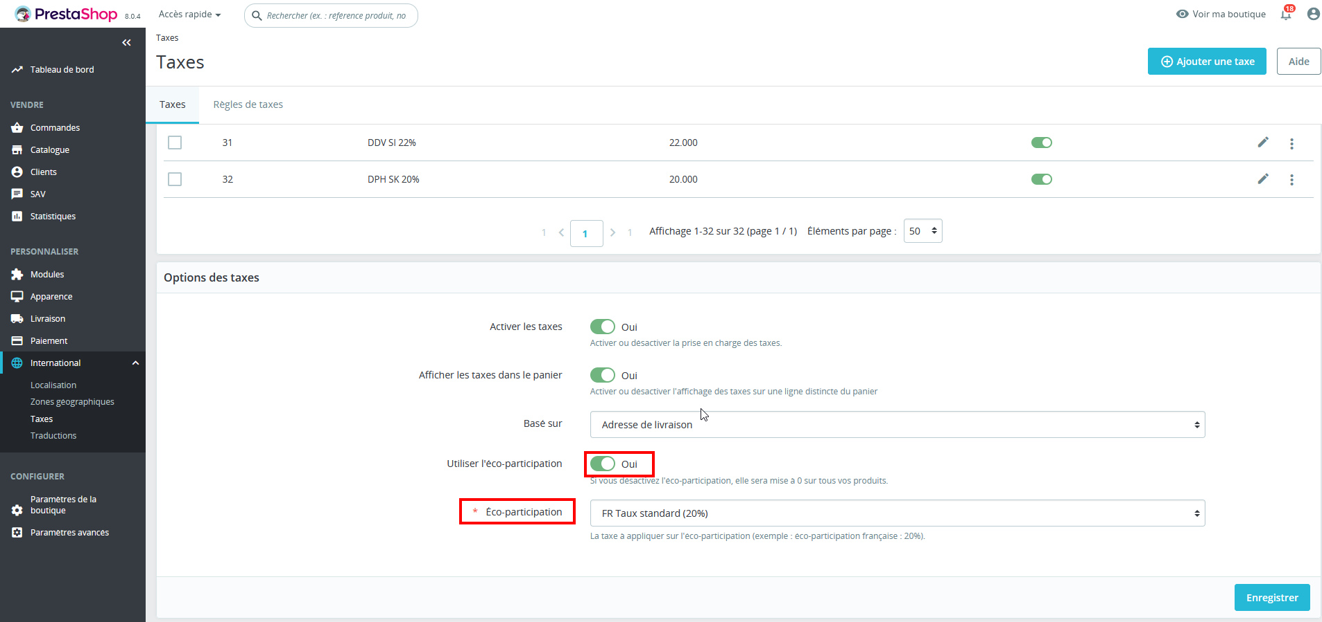
Dans Atoo-Sync GesCom EBP
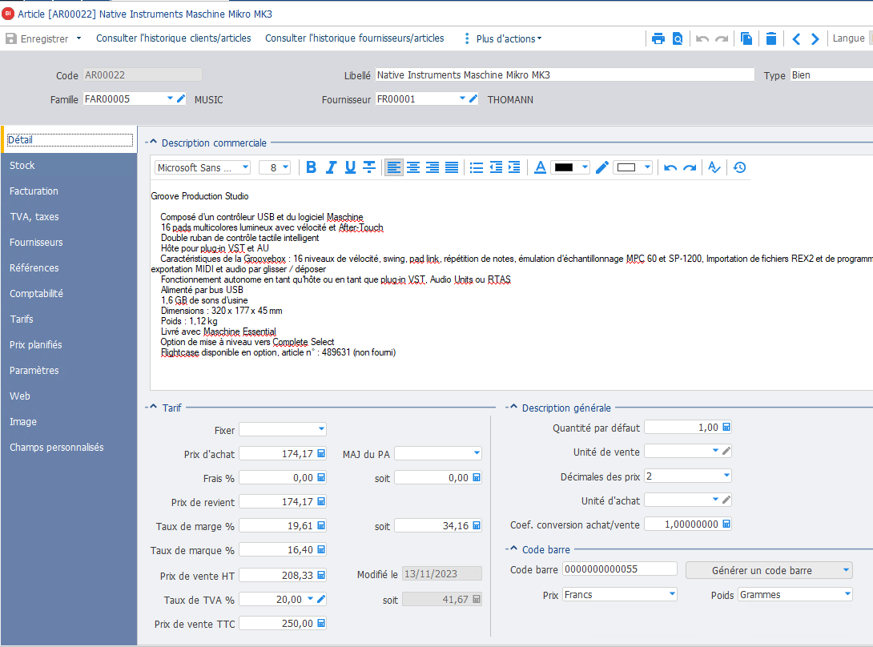
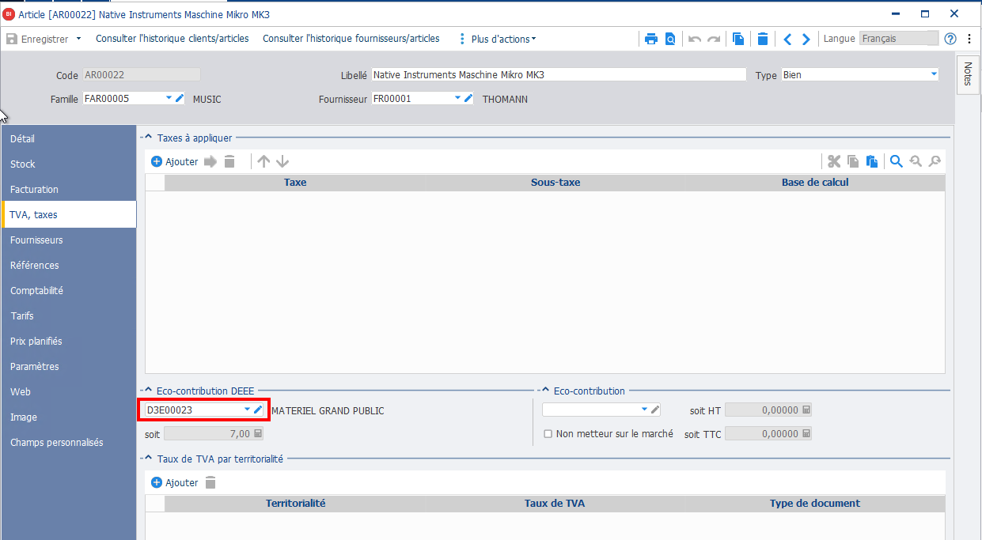
> Articles > coché "Soustraire l'écotaxe du prix du produit"
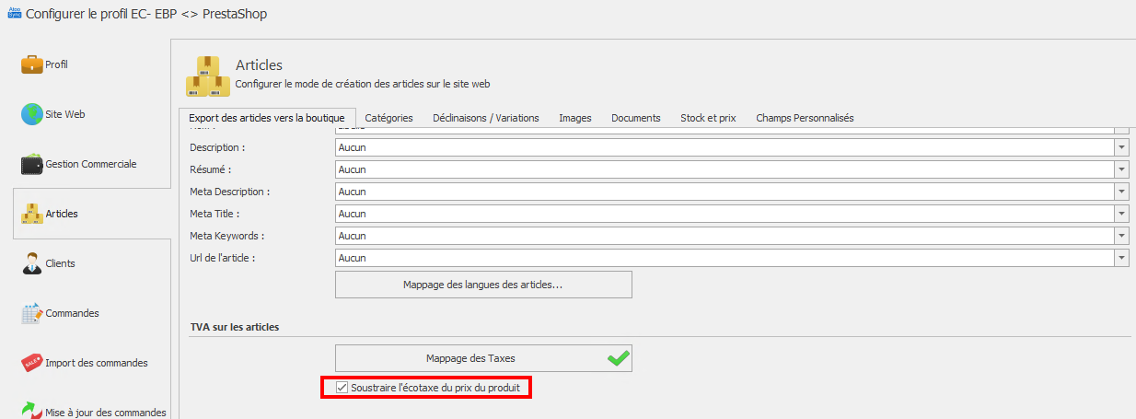
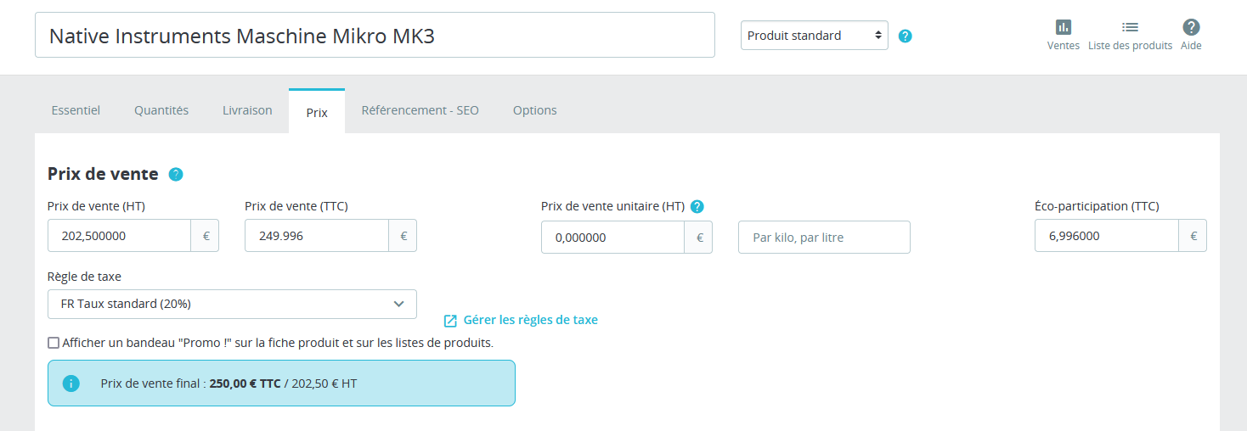
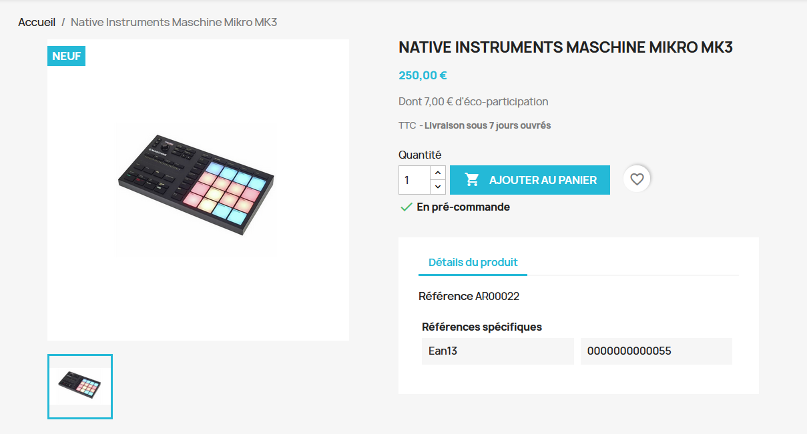
XML
<ecotax>5.83000</ecotax>
<quantity>0.00000</quantity>
<minimal_quantity>1.00000</minimal_quantity>
<price>202.50000</price>
<regular_price_tax_exclude>0.00000</regular_price_tax_exclude>
<regular_price_tax_include>0.00000</regular_price_tax_include>
<price_tax_exclude>202.50000</price_tax_exclude>
<price_tax_include>243.00000</price_tax_include>
<price_tax>40.50000</price_tax>
<tax_rate>20.00000</tax_rate>
<tax_rate_second>0.00000</tax_rate_second>
<tax_rate_third>0.00000</tax_rate_third>
<tax_rate_fourth>0.00000</tax_rate_fourth>
<tax_rate_fifth>0.00000</tax_rate_fifth>
<wholesale_price>174.17000</wholesale_price>

> Articles > décoché "Soustraire l'écotaxe du prix du produit"
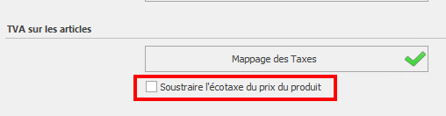
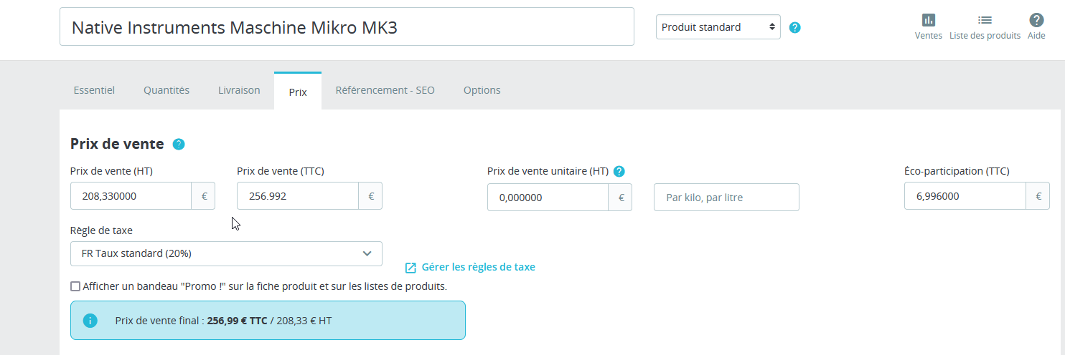
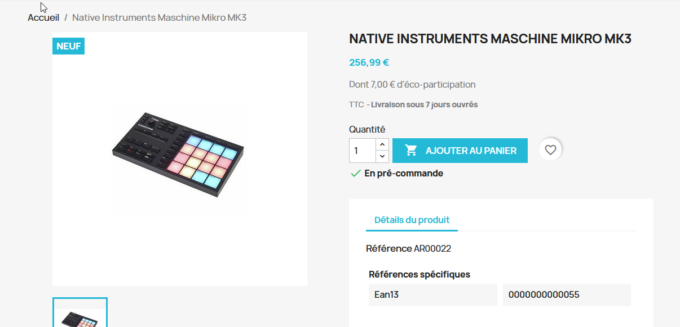

XML
<ecotax>5.83000</ecotax>
<quantity>0.00000</quantity>
<minimal_quantity>1.00000</minimal_quantity>
<price>208.33000</price>
<regular_price_tax_exclude>0.00000</regular_price_tax_exclude>
<regular_price_tax_include>0.00000</regular_price_tax_include>
<price_tax_exclude>208.33000</price_tax_exclude>
<price_tax_include>250.00000</price_tax_include>
<price_tax>41.67000</price_tax>
<tax_rate>20.00000</tax_rate>
<tax_rate_second>0.00000</tax_rate_second>
<tax_rate_third>0.00000</tax_rate_third>
<tax_rate_fourth>0.00000</tax_rate_fourth>
<tax_rate_fifth>0.00000</tax_rate_fifth>
<wholesale_price>174.17000</wholesale_price>

